**Environment Condition based Key findings**

Our current analysis reveals that while the majority of KSI collisions occur in clear weather conditions, adverse weather conditions such as rain and snow can significantly increase the likelihood of collisions resulting in major or fatal injuries. In particular, collisions during strong wind conditions have the highest rate of fatality, while drifting snow results in the most major injuries.

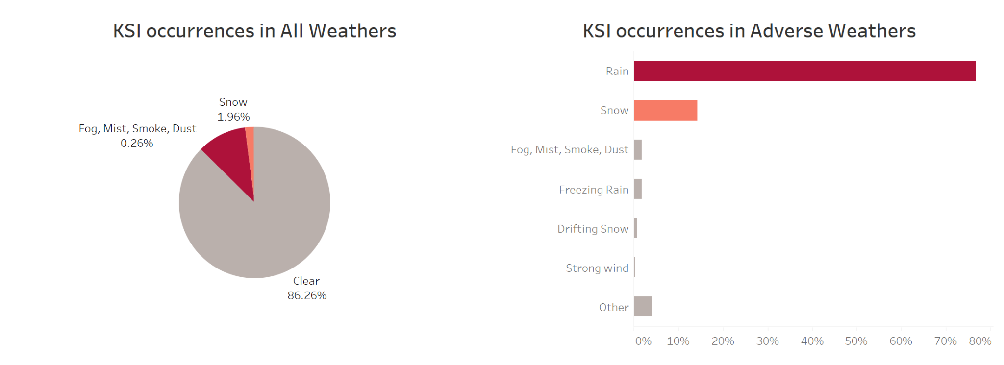

From the first figure, majority of KSI collisions (86%) occurred in clear weather conditions, which suggest the weather condition however is not a main factor contribute to KSI event. However, in order to investigate which adverse weather has the most impact on KSI collision, the clear factor is removed from the second figure. It shows rain and snow took major factors in that, while weather like strong wind and drifting snow are the least common reason for causing an KSI event. The reason for this is obvious, raining is the most common adverse weather in whole year in Toronto and snowing also always occurred in winter, which can wet road can easily cause vehicle drifting and collide.

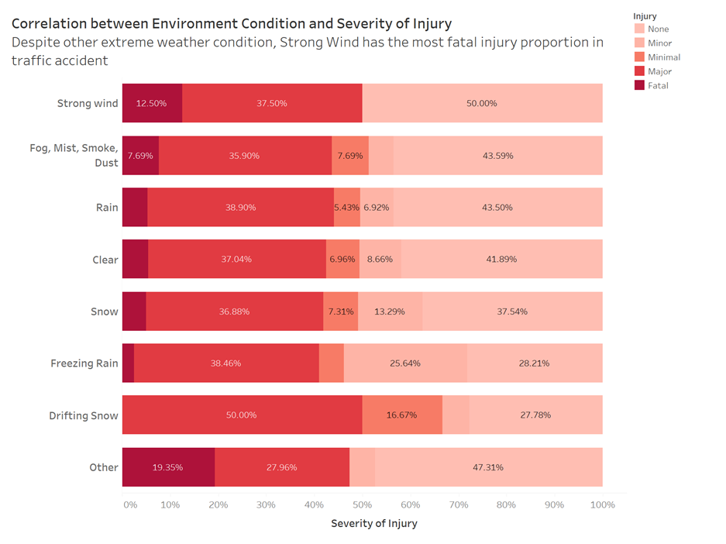

We also generate a bar chart in order to show how weather affects severity of injury for KSI. The severity of injury is divided into five levels: fatal, major, minimal, minor and none. From the above figure, collisions during strong wind conditions have the highest rate of fatality, while drifting snow results in the most major injuries. In strong wind condition, drivers may not drive as cautious as other extreme weather since they might not notice wind speed by sitting in a car. Vehicle can easily lose control while speeding in strong wind condition. In contrast, drifting snow is obvious for a driver, so he or she will drive with cautious in such weather. Another interesting fact from the graph is that the fatal injury and no injury are both in descending order. The weather that cause the most fatal injury is also having most no harm accident. It is possible that the weather condition itself may not be the sole determining factor for the severity of the collision. For example, a collision that occurs during clear weather conditions may be more likely to involve high speeds, which can lead to more severe injuries, while collisions that occur during adverse weather conditions may be more likely to occur at lower speeds due to decreased visibility or slippery road conditions, resulting in fewer fatalities but more minor harm accidents.

Based on the findings of this analysis, the following recommendations are suggested for reducing the impact of environmental conditions on KSI collisions:

1. Improving road maintenance during extreme weather conditions, such as snow, ice, and heavy rain, to ensure that the roads are safe for everyone.

2. Encourage the use of alternative modes of transportation, such as public transit, carpooling, and cycling, during adverse weather conditions to reduce the number of vehicles on the road.

3. Increase public education and awareness campaigns that promote safe driving habits during adverse weather conditions, such as slowing down, increasing following distance, and using proper winter tires.

**Reference:**

"Weather and Road Safety: A Synthesis of Research and Practice," a report by Dr. Jean Andrey Department of Geography, University of Waterloo: This report provides an overview of the relationship between weather and road safety, including how different types of weather conditions can impact visibility, pavement friction, and vehicle handling. This report is relevant to the KSI dataset as it provides a broader context for understanding how weather conditions can impact traffic collisions, and offers suggestions for how policy makers can improve road safety during adverse weather conditions. The report can be found at: <https://www.researchgate.net/publication/269038285_Weather_Information_and_Road_Safety>